**Nanoracks**

Ideally 1U

Rail Launch system

~$90,000 per 1U

51.6 degree inclination

385-400Km

**SpaceX**

Minimum 300k$ for a rideshare, might be the best option for launching multiple Cubesats as other providers might charge per satellite rather than by a minimum + extra for mass like SpaceX do. – We may need to package them together and plan for separation.

**GOMspace**

Offers better integrated packages for 5 year LEO missions with all required hardware – not an option for our mission.

**Rocket Lab**

Various launch locations, and we can deploy from 38 to 120 degrees up to 500km with ~ 1.5 degrees precision.

Mission very flexible.

Provides launch force and frequency information.

**Endurosat**

Cost calculator but uses external launch providers. Might be the easiest logistical option.

<https://www.endurosat.com/configurator/>

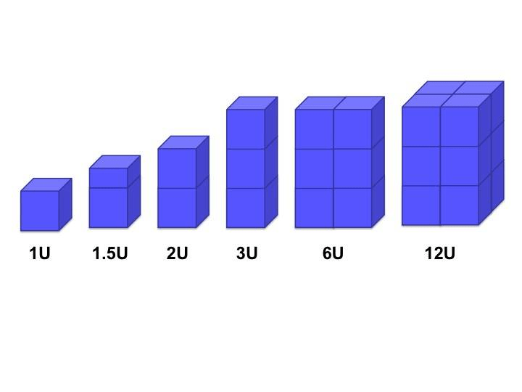

https://www.nasa.gov/wp-content/uploads/2015/03/what_are_cubesats.png

1U = 10cm x 10cm x 10cm

Typically ~ 1kg-1.3kg per 1U.

Ideal configuration will depend on volume of cold gas required for thruster, which will depend on target rotational speed for testing.

1U 2U or 3U should be target as they work with more providers and dispensers, but 1.5U would be ok.